Ghars International School: Healthy Eating Policy
According to the latest figures:
- There were over five times more medically acknowledged cases of child obesity in children aged 4-5, in comparison to 2006/7.
- In children aged 4-5, 9.5% of children are classed as obese. This figure is higher in children aged 9-11, marked at 19.5%.
- There is an ever-growing trend of obesity and excess weight in young boys more than young girls.
These statistics simply did not exist 100 years ago. In an ever declining world of health, we at Ghars International School seek to make a change to benefit the health of our children. We seek to educate about the importance of making good food choices and taking regular exercise, all to the ultimate goal of keeping our bodies healthy. Therefore, we hold a strong Healthy Eating policy, across the school.
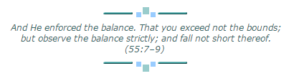
In the classroom, we continually teach and reinforce healthy lifestyle principles:
- The balance needed within a healthy diet e.g. protein, vitamins and the importance of other such nutrition.
- Which foods naturally contain important nutrition
- Alternatives to sugary foods
- The damage of sugar on the body and on the teeth
- Dental and personal hygiene
- Various ways to exercise that are attainable to small children
- The importance of healthy bones in a healthy body
- Drinking enough water a day
We ask that parents support us in our Healthy Eating policy. Packed lunches should have a healthy balance with foods that contain vegetables, proteins and dairy products over sugary or high cholesterol foods. We encourage parents to send with their child
- Portion of fruits and vegetables
- Water or milk
- Cheese or meats
Food that is prohibited:
- Fizzy drinks/soda
- Sweets and cakes
To read further about making an enjoyable and healthy life style change, please visit the website, Change4Life, at:
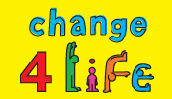
http://www.nhs.uk/change4life/Pages/change-for-life.aspx
Or simply type in ‘Change4Life’ into google.

http://www.hscic.gov.uk/catalogue/PUB16988/obes-phys-acti-diet-eng-2015.pdf

